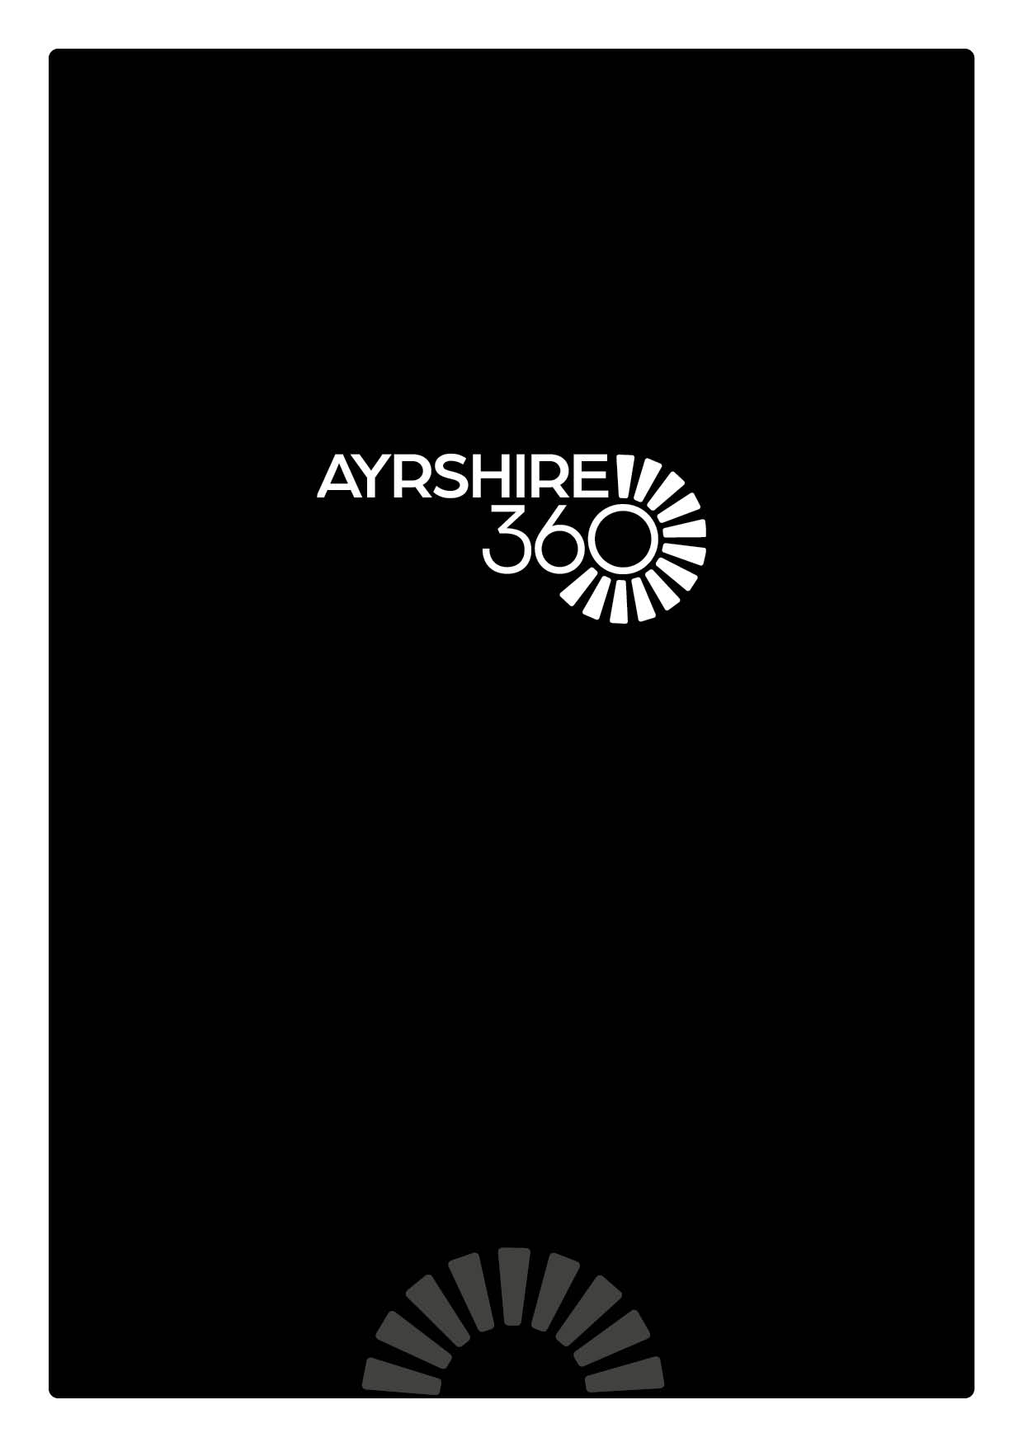

RISK MANAGEMENT CONTROL BULLETIN

Property Insurance: Winter/Severe Weather Risks (including the Christmas and new Year Shut Down)
INDEX

Page No.

1 BACKGROUND 3

2 ISSUES 3

3 CONTROL MEASURES
3.1 All Properties – Water Apparatus 3
3.2 Fire 4
3.3 Security 5
3.4 Sprinklered Properties – Wet Systems 5

1 BACKGROUND

The purpose of this guidance note is to minimise the risks of bursting of water apparatus during the winter months and the risks of fire and of opportunistic theft during the Christmas and New Year holiday period.

2 ISSUES

2.1 The accidental bursting or overflowing of water apparatus, due to a sudden and unexpected dip in temperature, could mean that such an escape of water goes undetected causing widespread damage.

2.2 The extended annual leave period potentially creates additional threats and/or increased threats from:-

- Fire – both deliberate and accidental.
- Theft – especially where there is a concentration of thief attractive high value goods and/or materials.

3 CONTROL MEASURES

3.1 All Properties - Water Apparatus

- Ensure that heating will be maintained to provide at least frost protection level during the shutdown period.

- Ensure all doors are closed.

- Ensure that all valuable equipment and files are not left at ground/floor level. Any vulnerable/ or sensitive files or materials must be adequately stored/protected.

- Where fitted ensure that the sprinkler systems weekly check has been carried out and the system is fully operational. Check that there are no obstructions which would block the successful operation of the sprinkler heads.

- Any exposed pipework should be appropriately lagged. Where pipework is already lagged ensure lagging is not damaged and that no pipework is exposed.

- Know where the stop valve is located. This should be accessible and clearly identified.

- Dripping water increases the risk of freezing, so have any leaks at taps or valves repaired as soon as you discover them. Ensure that all taps are fully off as running taps may cause waste pipes to freeze. Ensure plugs are not left in position in sinks.

- Cold draughts also increase your heating bills and can cause frozen pipework. Draughts can be reduced by fitting draught excluders to doors and windows.

- Any water tank should be fitted with an insulation jacket or alternatively, the top and sides of the tank can be wrapped with suitable insulation material.

- Don’t place loft insulation under the tank though, as this stops heat from the rooms below helping to keep the tank warm.

- If there are toilet cisterns, water tanks or pipes in exposed places or unheated outbuildings, make sure these are insulated. If not in use, however, drain them for winter.

- Check that the overflow pipes on water tank cisterns are of adequate size and have unobstructed discharge to a purposeful place – not onto the floor.

- Service heating systems regularly and ensure thermostats / frost stats are working correctly and set appropriately. In periods of sub-zero temperatures, the heating system and other special frost protection provision should be operating at all times. Consider installing thermostats and frost stats if not already in place.

- It is recommended that when insulating pipes it's best to ensure you buy good quality insulation, and remember, the thinner the pipe the thicker the insulation must be. As a guide, a 15mm or 1/2" pipe needs insulation which is 25mm thick, a 28mm or 1" pipe needs insulation which is at least 19mm thick.

3.2 Fire

The following checklist is not exhaustive but may ensure that the building is protected as far as is possible:-
- Ensure that there is no accumulation of combustible materials in/around the premises.

- Ensure that all windows and doors are secured and that all smoke detectors, burglar alarms, CCTV and other fire/security devices are fully operational.

- Ensure that all fire doors are fully closed before leaving the premises. A fully operational fire door will provide at least 30 minutes fire spread prevention and will minimise the risk of extensive smoke damage.

- Ensure that all electrical appliances which are not intended and designed to be left on stand-by or to be operational 24/7 are switched off/disconnected from the power supply at source.

- Please pay particular attention to Christmas tree lights and to auxiliary portable electrically operated heaters, to ensure that all are switched off.

- Where provided, wheelie bins should be stored within secure bin stores.

- Ensure all lights not intended/designed to operate out of hours are switched off.

- Ensure that all critical documentation is contained within secure/lock-fast metal filing cabinets and that all IT systems are backed up accordingly.

- Where fitted ensure that all blinds are left in the closed position

3.3 Security

- Ensure that all windows and doors are secured.

- Ensure that all burglar alarms and CCTV systems, where installed, are fully operational and that all valuable/thief attractive items are contained within a secure environment. In particular do not obstruct the operation of alarm detector units (PIRs) by the presence of Christmas trees or decorations.

- Ensure that where provided for use in conjunction with CCTV that perimeter lighting is operational.

- No alarm code details should be left on the premises.

3.4 Sprinklered Properties - Wet Systems (those permanently containing water)

- Where pipework is ‘trace heated’ ensure that the electrical circuit is in working order and is switched on.

- Where pipework is lagged a check should be made to ensure that such lagging is not damaged and that no pipework is exposed.

- All areas of the premises except those where special winter protection has been installed must be adequately heated – minimum 4 º C at all times.
- Particular attention should be paid to areas above false ceilings, roof voids, toilets, cloakrooms and areas near large door openings.

- Where installed, all parts of the system which are controlled by a supplementary air valve must be put on air at the end of September.

- System drainage arrangements should be checked so that under test conditions, water damage and dangerous ice conditions do not occur. The overflow pipe in some facilities does not flow into a drain and could create a hazard in icy conditions when the system is tested.

- The weekly sprinkler test must be carried out and findings recorded on the test card.

- Alarm monitors - either water or electric and all associated signalling connections should be checked weekly to make sure that they are in full working order.

- Pump rooms must be adequately heated – minimum 10º C at all times for those containing diesel pumps and 4º C for electric motors. It may be necessary to take steps to avoid heat loss through the louvers in doors to the pump houses. It must be remembered, however that a sufficient area needs to be provided for the aspiration of any diesel engine. Where fitted the diesel pump must be regularly tested and the fuel supply topped up.

- Staff must be aware of the action that needs to be taken in the event of the sprinkler system leaking or a reduction in temperature occurring.

- Lack of adequate heating may contravene the Trust’s insurance policy conditions.

In respect of system failures arising under 3.1, 3.2, 3.3 or 3.4 alert EAC Risk & Insurance and EAC Risk Management Centre immediately by phone/e-mail in order that temporary risk control measures may be considered.

