
- OBJECTIVE AND SCOPE

Violence and Aggression in the Workplace is one of several health and safety management standards forming the Trust’s Health, Safety and Wellbeing Policy written arrangements in compliance with general duties under the Health and Safety at Work Act 1974

Violence or aggressive behaviour directed towards Trust employees whilst they are at work, whether physical or verbal is unacceptable. This Standard outlines the corporate policy and procedures to address incidents of work-related violence and aggression.

- RESPONSIBILITY

Overall responsibility for the implementation of this standard belongs to Directors and Strategic Leads. Development Managers, Officers and Co-ordinators are responsible for ensuring arrangements are fully implemented within their areas of control.

Services need to supplement this standard with written local arrangements which are in place including, risk assessments and controls to reduce the risks associated with violence and aggressive behaviour, as far as reasonably practicable.

CONTENTS

1 INTRODUCTION 2
2 DUTIES & RESPONSIBILITES 2
2.1 Senior Management 2
2.2 Development Managers and Officers 2
3.3 Employees 3
3 VIOLENCE AT WORK 3
3.1 Definitions of Work Related Violence 3
3.2 Who Is At Risk? 3
3.3 Risk Factors 4
3.4 Post incident Response 4
3.5 Risk Assessments 6
3.6 Lone Working 7
3.7 Preventative Strategies 7
3.8 The Physical Environment 8
3.9 Security Measures 8
3.10 The Work Task/Activity 9
3.11 Employee Behaviour 9
3.12 Training and Information 10
3.13 Reporting Incidents of Violence 11
4 FURTHER INFORMATION 11
4.1 Contact Information 11
4.2 External Source of Information 11

APPENDIX 1 – Violence and Agression Policy Statement
APPENDIX 2 – Workplace Violecnce and Agression Poster
APPENDIX 3 – Violence and Aggression Reporting Charter
APPENDIX 4 – Violence and Aggression Incident Debrief Guide for Managers

INTRODUCTION

The Health and Safety at Work etc. Act 1974 requires that reasonable steps are taken to protect the health, safety and welfare of employees whilst they are at work. This includes provisions to protect employees against incidents of violent and aggressive behaviour directed towards them, as far as is reasonably practical.

Violent and aggressive behaviour of any form, directed towards any Trust employees at work is unacceptable. Any person abusing a Trust employee may be subject to legal action and/or restriction in service provision.

The Trust’s Violence and Aggression Reporting Charter sets out Senior Management’s absolute commitment towards reducing risks and ensuring that employees who are subjected to physical or verbal abuse while at work, are encouraged to report incidents and provided with appropriate support.

Directors and Strategic Leads have overall responsibility for implementing preventative and control strategies to reduce violence and aggression towards employees. Managers/Officers must ensure that risk assessments identify potential risk of violent, abusive and aggressive behaviour towards their employees and that appropriate measures are taken to prevent or reduce these risks, as far as reasonably practical.

DUTIES AND RESPONSIBILITIES

  - Senior Management

The Chief Officer, Directors and Strategic Leads support a culture whereby all managers and employees will be encouraged and supported to report all incidents of violence and aggression in the workplace; a commitment that is underpinned by the Violence and Aggression Reporting Charter

Strategic Leads have overall responsibility for ensuring that suitable risk control strategies are in place to identify and reduce any foreseeable violence and aggression risks arising from the work activities carried out within their services.

  - Development Managers and Officers

Managers must ensure that suitable and sufficient risk assessments are in place where risks of incident of violent, aggressive or abusive behaviour have been identified in work areas under their control and implement suitable and sufficient risk control measures to prevent or reduce those risks, as far as reasonably practical.

Where violence and aggression towards employees has occurred, managers must offer support and discuss with the employee any preventative actions which need to be taken and any further measures which can be put in place to minimise the risk of occurrence.

  - Employees

Employees have a duty to protect their own health and safety and must therefore comply fully with any training and instruction given, including following any control measures provided in risk assessments, related to violence and aggression.

Incidents of violence and aggression, regardless of the type or severity must be reported to line management and recorded on the SHE incident reporting system.

All employees who are subjected to violence and aggression in the workplace have the right to seek support, advice and guidance from their trade union at any time they feel is appropriate, and are encouraged to do so.

3. VIOLENCE AT WORK

  - Definition of work-related violence

The Health and Safety Executive’s (HSE) definition of work-related violence is ‘any incident in which a person is abused, threatened or assaulted in circumstances related to their work’.

Violence at work and its threat can affect the psychological and physical wellbeing of employees and may lead to low morale, stress and absenteeism.

Workplace violence includes:
- Physical attacks
- Threatening behaviour, such as throwing objects and destroying property
- Verbal threats, including those made by phone, email or online
- Abusive language, such as racial/sexual abuse and derogatory comments, made verbally or in writing
- Posturing
- Harassment or intimidation

Incidents of violence can be:
- Instigated by service users, members of the public, children and young people or work colleagues
- A single incident or involve more systematic patterns of behaviour
- Range from minor incidents to more serious acts, including criminal offences which require police intervention.

  - Who is at risk?

While violent, aggressive or abusive behaviour can occur during any personal interaction, either face to face or remotely e.g. over the telephone or on-line, employees who mainly deal with the public and lone workers are most at risk of violence in the workplace. Within Trust services, those who work in the following environments are generally at higher risk of violence & aggression:

    - Frontline staff in public facing roles (face to face contact, online and by telephone)
    - Public places, for example, employees who work outside
    - Employees who work in the community

Violent, aggressive or abusive behaviour towards employees arises primarily because the work involves contact with a wide range of people in potentially challenging circumstances, including:

    - Providing or withholding a service
    - Receipt of negative correspondence, for example debit recovery, upholding the no refund policy
    - Lone working
    - Out of hours working
    - Travelling and working in the community
    - Carrying out inspections or enforcement duties
    - Working with children, young people and adults who have additional support needs or emotional or behavioural issues
    - Working with people under the influence of alcohol or drugs
    - Working with people with mental health issues.

  - Risk Factors

The HSE have identified individual risk factors which could lead to violent and aggressive behaviour, including:
    - Impatience (due to unreasonable waiting times, lack of information and boredom)
    - Frustration or anger often as a result of dysregulated behaviour or trauma
    - Anxiety (lack of choice, lack of space, unreasonable waiting times)
    - Resentment (perceived infringement on rights)
    - Use of alcohol/drugs

These risk factors could lead to violent behaviour and need to be considered within the risk assessment process. For example, it is reasonably foreseeable that people waiting in a reception area for prolonged periods will become impatient and frustrated, therefore clear processes need to be in place to ensure assistance is provided promptly to help reduce the risk of any potentially aggressive behaviours.

3.4 Post Incident Response

Managers of employees who have been subjected to violence at work should be aware of its potential impact on the individual and offer appropriate post incident support.

Following a violent incident, the priority must be for the victim’s wellbeing and the need for medical treatment should this be required. In the event of a physical assault resulting in injury, appropriate medical assistance should be sought and the employee’s line manager notified as soon as possible. In these circumstances it may be appropriate to contact the Police.

Incidents of violence and aggression towards employees must be reported through the SHE system and it is important to gather as much information about the incident as soon as possible. This should include the assailant’s details and any witness statements to enable accurate recording and provide information should a formal investigation be required.

Managers should meet with the employee who has been subjected to the incident as soon as possible to discuss the circumstances and offer support, including referral to the Trust’s Employee Counselling Service or PAMS where appropriate.

An incident debrief guide has been developed to assist managers with this process, Violence and Aggression Incident Debrief Guide for Managers.

It is recognised that in some circumstances a formal meeting will be neither practical nor required by the employee; for example in cases of non-threatening verbal outbursts (venting) or known behaviours. Therefore, depending on the type and circumstances of the incident, it may be sufficient to record the incident on the SHE systems without a post incident debrief.

However, employees must always be encouraged to report any incident of violence and aggression regardless of the severity or the circumstances surrounding it.

Where there is frequent violence and aggression, for example, involving the same assailant or employee; managers must follow internal procedures by supporting the person involved, review the controls within the risk assessment and ensure that incident(s) are recorded on the SHE system.

Key Points to remember

- Employees must report all instances of violent, abusive behaviour towards them.
- The wellbeing of the employee is paramount and any medical attention required must be provided as soon as possible.
- Managers must offer appropriate support to the employee, which may include time out or referral to employee counselling, as appropriate,
- The risk assessment must be reviewed appropriate to the circumstances of the incident, for example, incidents considered to be minor by the employee may simply require discussion between the manager and employee and reported on SHE. More serious or repeated incidents will require review of the risk assessment, with input from the employee and support from Trade Unions, with any actions taken or additional controls implemented being fed to the employee, and broader workgroup as appropriate.
- The Police should be notified by the responsible manager, in cases of physical assault or direct and serious threats and intimidation, unless it has been agreed between the employee ad manager that Police involvement is not necessary.

3.5 Risk Assessment

The first step in the prevention of violence is to complete a risk assessment. The assessment should look at the specific work locations, work activities or in some cases, individual service users where there is a potential risk of violence.

Assessments should be carried out by managers/officer with an understanding of the work activity. Trade Union representatives and/or employees should be consulted throughout the assessment process and encouraged to contribute suggestions as to how risks can be reduced.

Types of violence in the workplace should be considered in the same way as any other hazard. The risk assessment should:

    - Identify the risk of violence associated with the work location, the activity and exposed employees
    - Record any current risk control measure/s
    - Evaluate the risk and potential severity of violence
    - Decide on whether additional risk control measures are required to further reduce the risk to employees
    - Communicate and implement the completed assessment to employees at risk
    - Monitor and review the risk assessment to ensure it remains effective

The assessment process should not be restricted to violent incidents which have already occurred but should also consider any known patterns of violence in other similar work locations or activities, both within and out with the Trust.

Some employee groups may be more vulnerable to the risk of violence than others, for example new or expectant mothers, young or inexperienced workers or those with protected characteristics under the Equalities Act.

The information gathered during the risk assessment process should identify significant risks and enable management to:

    - Clearly identify the locations or activities where employee interaction with others could place them at risk from violence
    - Determine if existing controls are sufficient or whether additional controls are required
    - Provide employees with information, instruction and training to help minimise risk to themselves.

Key Points to remember

- Managers must undertake a risk assessment when there is a foreseeable risk of violence and aggression in the workplace.
- Trade Unions, employees and other key contributors, for example the Health & Safety Strategy Group, should be consulted in drawing up the risk assessment, as appropriate.
- The content of the risk assessment and control measures introduced to reduce the risk of violence and aggression, must be communicated to employees and others who may be exposed to the risk in a way that is understood, for example, provision of tool box talks or simple written guidance.
- Following an adverse incident, the risk assessment must be reviewed and updated. Any new control measures introduced following the review should be communicated to employees and others who may be exposed to the risk

3.6 Lone Working

Lone workers are employees who work by themselves without any close or direct supervision. In some situations this may make them more susceptible to the risk of violence, particularly when working with people with unpredictable behaviour, providing services to people in their own homes or travelling and working in remote locations.

Lone working should be considered within the risk assessment process where it could increase the risk of violence towards an employee.

The most common risks associated with lone working are:-

    - Geographical locations with increased violence risk
    - Working with or coming across alcohol and drug users
    - Nature of the job, for example Development Assistant (Countryside)
    - Late evening/early morning work or unsocial hours
    - Behaviour of the service user or member of the public. For example, highly emotional, unpredictable or aggressive

As part of the process five key questions should be asked:

    - Can the work be undertaken safely by a single person?
    - Is there a “flag” or alert in place about lone working at a venue?
    - Is the employee medically fit and able to work alone?
    - Is the employee more vulnerable to working alone than others, for example new or expectant mothers or young/ inexperienced workers?
    - What arrangements are required to ensure the lone worker is at no more risk than employees working together?

These key questions will act as a helpful prompt when identifying the risks of violence and aggression towards employees who work alone.

Further information can be found in the Lone Working Standard

3.7 Preventative strategies

An effective method to eliminate or reduce the risk of violence is to plan, design and organise the work activity in a way which minimises employee exposure to potential risks.
Managers should continually review the working arrangements to determine if there are adequate precautions or whether more is required to reduce the risk. It is likely that a combination of preventative strategies will be required to manage any identified risks effectively.

Factors which should always be considered when determining suitable risk control measures are:
    - The physical environment
    - Security systems
    - The design of the work activity
    - Training and information provided to employees.

3.8 The physical environment

It is important that employees working in Trust buildings feel safe. Good design and physical security planning can, in part, help to achieve this by reducing the risk of violent incidents. The physical environment should therefore always be considered within the overall preventative strategy.

Public areas, such as receptions and service desks, or outdoor areas such as school playgrounds should provide adequate security and protection for employees, whilst still allowing effective contact and communication with service users or members of the public. These areas should be designed with good visibility as well as methods to prevent unauthorised access.

Some other examples of ways the physical environment can help to reduce the risk of violence and aggression include:

    - Corporate signage clearly stating that violence towards Trust employees will not be tolerated
    - Clear directional signage and instructions for visitors and service users to help prevent impatience and irritation
    - Avoiding any objects within these areas which could potentially be used as a weapon or thrown
    - Specially designed counters e.g. extended counters to prevent grabbing or striking
    - Protective screens around public interface/ cash handing desks

Positive environmental features which are known to reduce the risks from people becoming impatient and irritated, thereby reducing the risk of violent and aggressive behaviour, includes:

    - The use of colour and lighting to influence mood e.g. bright and comfortable reception areas painted in pastel colours
    - Noise reduction
    - Provision of clear information screens

Environmental control measures need to be backed up with procedures which ensures engagement with service users in a timely and respectful manner, as well as providing prompt and adequate information.

3.9 Security measures

There may be circumstances where the building layout or personal security issues increases the risk of violent incidents to employees. The risk assessment should take individual situations into account when identifying the required security measures, and utilise appropriate procedures or systems to reduce the risk, for example:

    - Restricting access times where appropriate
    - Restricting entrance/exit points
    - Installing entry control systems
    - Installing surveillance systems
    - Installing fixed panic buttons
    - Issuing personal alarms
    - Means of communication i.e. phones

  - The work task/activity

Where a work task or activity has an identifiable risk of violence and aggression, managers should consider ways of altering work patterns to reduce the risks to employees or others.

Suitable precautions should be put in place for those who work within the community or working in areas of known violent incidents, for example:

    - Leaving itineraries of visits/working sites with a responsible person
    - Checking records for previous incidents of violent behaviour
    - Carrying out duties in pairs
    - Carrying a personal alarm and mobile phone
    - Reporting back to base or a nominated personal at scheduled intervals
    - Keeping meeting calendars up to date and ensuring the movements of employees who are lone working is known
    - Having clear escalation procedures in place for when employees cannot be contacted
    - Bringing service users into the base for meetings rather than meeting in their home

Employees should always be provided with information to enable them to identify service users with a violent history, or anticipate situations which might develop into violent or confrontational behaviour.

  - Employee behaviour

Employees have responsibility for their own behaviour and should act in a way that does not provoke or increase the possibility of violence occurring. Techniques should be applied to help to de-escalate an incident i.e. trying to defuse a confrontational situation and avoid violence. These include:

    - Acting responsibly at all times
    - Communicating effectively e.g. keeping people informed when they might be kept waiting
    - Avoiding confrontation, especially in front of an audience. Minimising the number of people involved in an incident makes it easier for someone to back down without losing face
    - Giving the person space, staying calm and speaking slowly, calmly and precisely so as not to be drawn into heated argument
    - Allowing the person to speak without interruption
    - Avoiding aggressive or disinterested body language such as:
- standing directly in front of or moving too close to the person
- finger pointing or adopting aggressive/disinterested body posture, such as lowering the gaze, standing over someone, folding arms or putting hands in pockets, and
- maintaining constant eye contact
    - Avoiding raising the voice or becoming argumentative

  - Training and Information

The Trust recognises that employees may be faced with challenging, distressing or violent and aggressive behaviour as they carry out their duties. Those who may be exposed to violence and aggression in the workplace need to be aware of the risks and how to deal with them.

There are two conflict handling eLearning courses available to employees which provide an understanding of the potential triggers leading to violent and aggressive behaviour. The courses provide useful strategies to recognise the early signs of potentially violent situations and techniques on how to manage them positively.

The modules undertaken should be appropriate to the employee’s duties and the associated risks. The modules are:

Conflict Handling – On The Phone

This module is aimed at any employee who answers calls from the general public as part of their duties. The course content covers:

- Common causes of challenging telephone calls
- Caller reactions and behaviours that can be termed ‘challenging’
- Good practice and practical steps employees can take to help the customer and avoid escalation
- Explain the ‘3 step approach’ to dealing with offensive behaviour

Conflict handling training is supplemented with enhanced training provision where the risk assessment determines that it is reasonable to anticipate that staff may have to use interventions beyond the scope of the conflict escalation techniques taught in the above course.

It should be noted that crisis management training is not a substitute for safe systems and safe places of work; it should be seen as part of an overall risk assessment and preventative strategy.

  - Reporting incidents of violence and aggression

All incidents of violence towards employees must be reported through the Trust’s incident reporting system (SHE). This enables trends, patterns or identifies habitual offenders, and helps to refine strategies for the reduction of violence and aggression in the workplace.

Acts of violence which occur directly between members of the public or services users do not require to be reported on SHE, where there has been no employee involvement.

Further information on the Trust’s incident reporting system can be found in the Incident Reporting Standard

- FURTHER INFORMATION

4.1 Contact Information

Health and Safety Strategy Group, Ayrshire360
E Mail: EALHealthandSafety@ayrshire360.com
Intranet: Health & Safety

Health and Safety Section East Ayrshire Council
E Mail: healthandsafety@east-ayrshire.gov.uk
EAC Intranet: Health and Safety

  - External Sources of Information

Further useful information about violence in the workplace can found in a number of Health and Safety Executive (HSE) guidance documents including:
Preventing workplace harassment and violence
http://www.hse.gov.uk/violence/preventing-workplace-harassment.pdf

Violence at work: A guide for employers
http://www.hse.gov.uk/pubns/indg69.pdf

Violence in health and social care http://www.hse.gov.uk/healthservices/violence/index.htm

Working alone
http://www.hse.gov.uk/pubns/indg73.pdf

General information
http://www.hse.gov.uk/violence/information.htm

WORKPLACE VIOLENCE POLICY STATEMENT

Violence at work can be defined as “Any incident in which an employee is abused, threatened or assaulted in circumstances relating to their work”

The Trust is committed to reducing acts of violence directed towards employees while at work. Directors and Strategic Leads view violent or aggressive behaviour as unacceptable and any person known to abuse Trust employees, either verbally or physically may be subject to legal action and/or a restriction in service provision.

Violence and aggression behaviour directed towards employees will be reduced as far as is reasonably practicable. This will be achieved by adopting a risk assessment approach and having in place effective preventative strategies and interventions to minimise the risk to employees.

The guidance provided in the Violence in the Workplace Standard, supports this Policy Statement and is designed to help managers ensure that:

- The risks of violence to employees in the workplace are identified and assessed, as far as is reasonably practical

- Trade Union and employees are actively involved in the risk assessment process and the outcome of assessments are fully communicated to those at risk

- Suitable preventative strategies and interventions are developed and implemented within Trust workplaces where there is a risk of violence and aggression

- Employees are provided with information, instruction and training to enable them to avoid and/or deal effectively with potentially violent and aggressive behaviour in the workplace

- Employees are actively encouraged to report incidents of violence through the Trust’s SHE incident reporting system to enable trends, patterns or habitual offenders to be identified

- Post incident support mechanisms for individuals who have been the victim of violence and aggression at work are in place.

WORKPLACE VIOLENCE INFORMATION POSTER

Poster can be found on the intranet via the following link: here
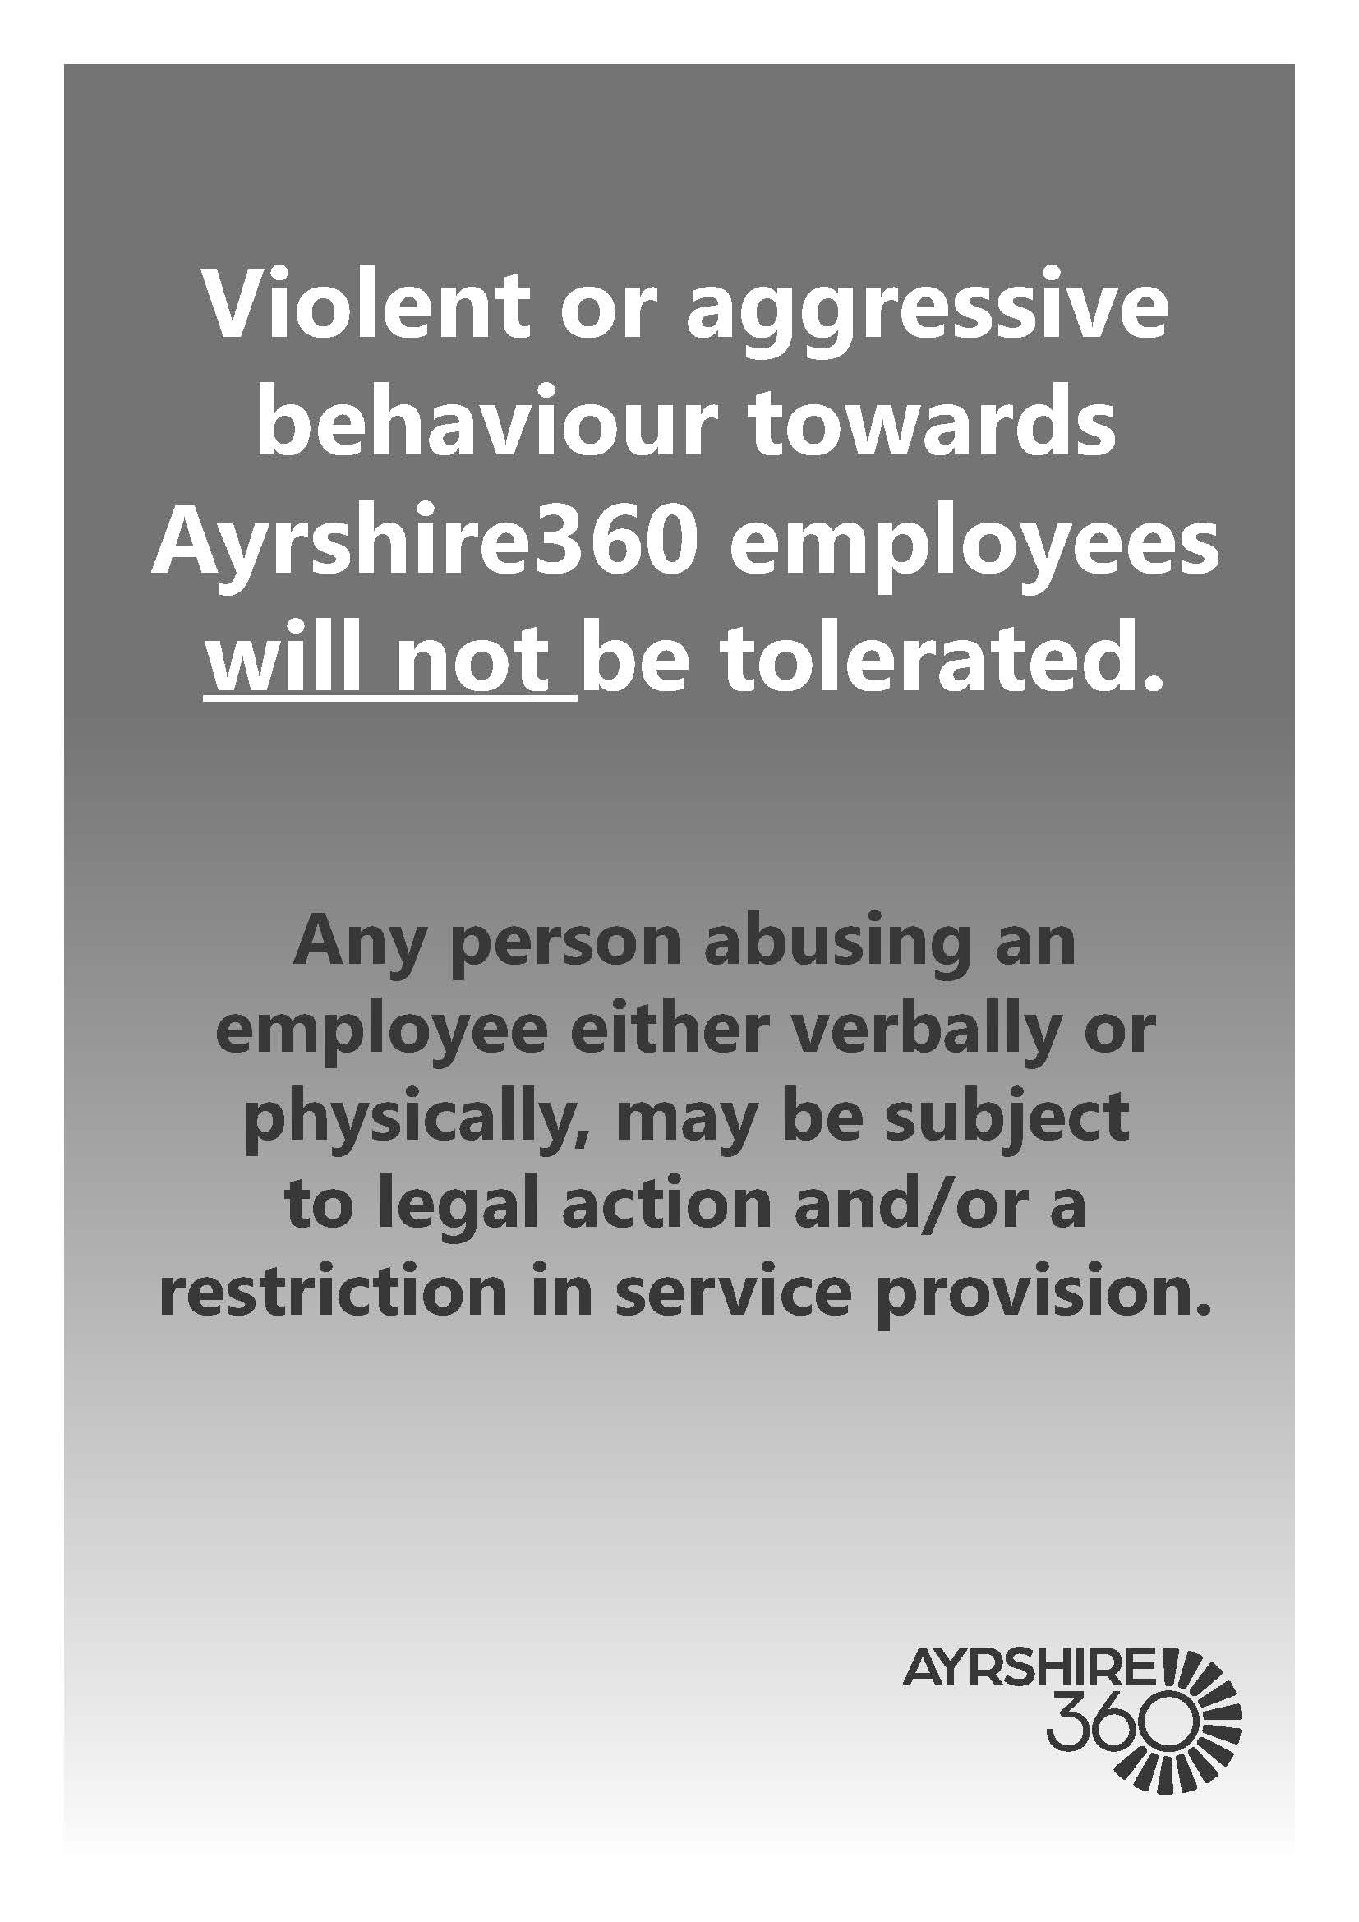

VIOLENCE AND AGGRESSION REPORTING CHARTER

Poster can be found on the intranet via the following link: here

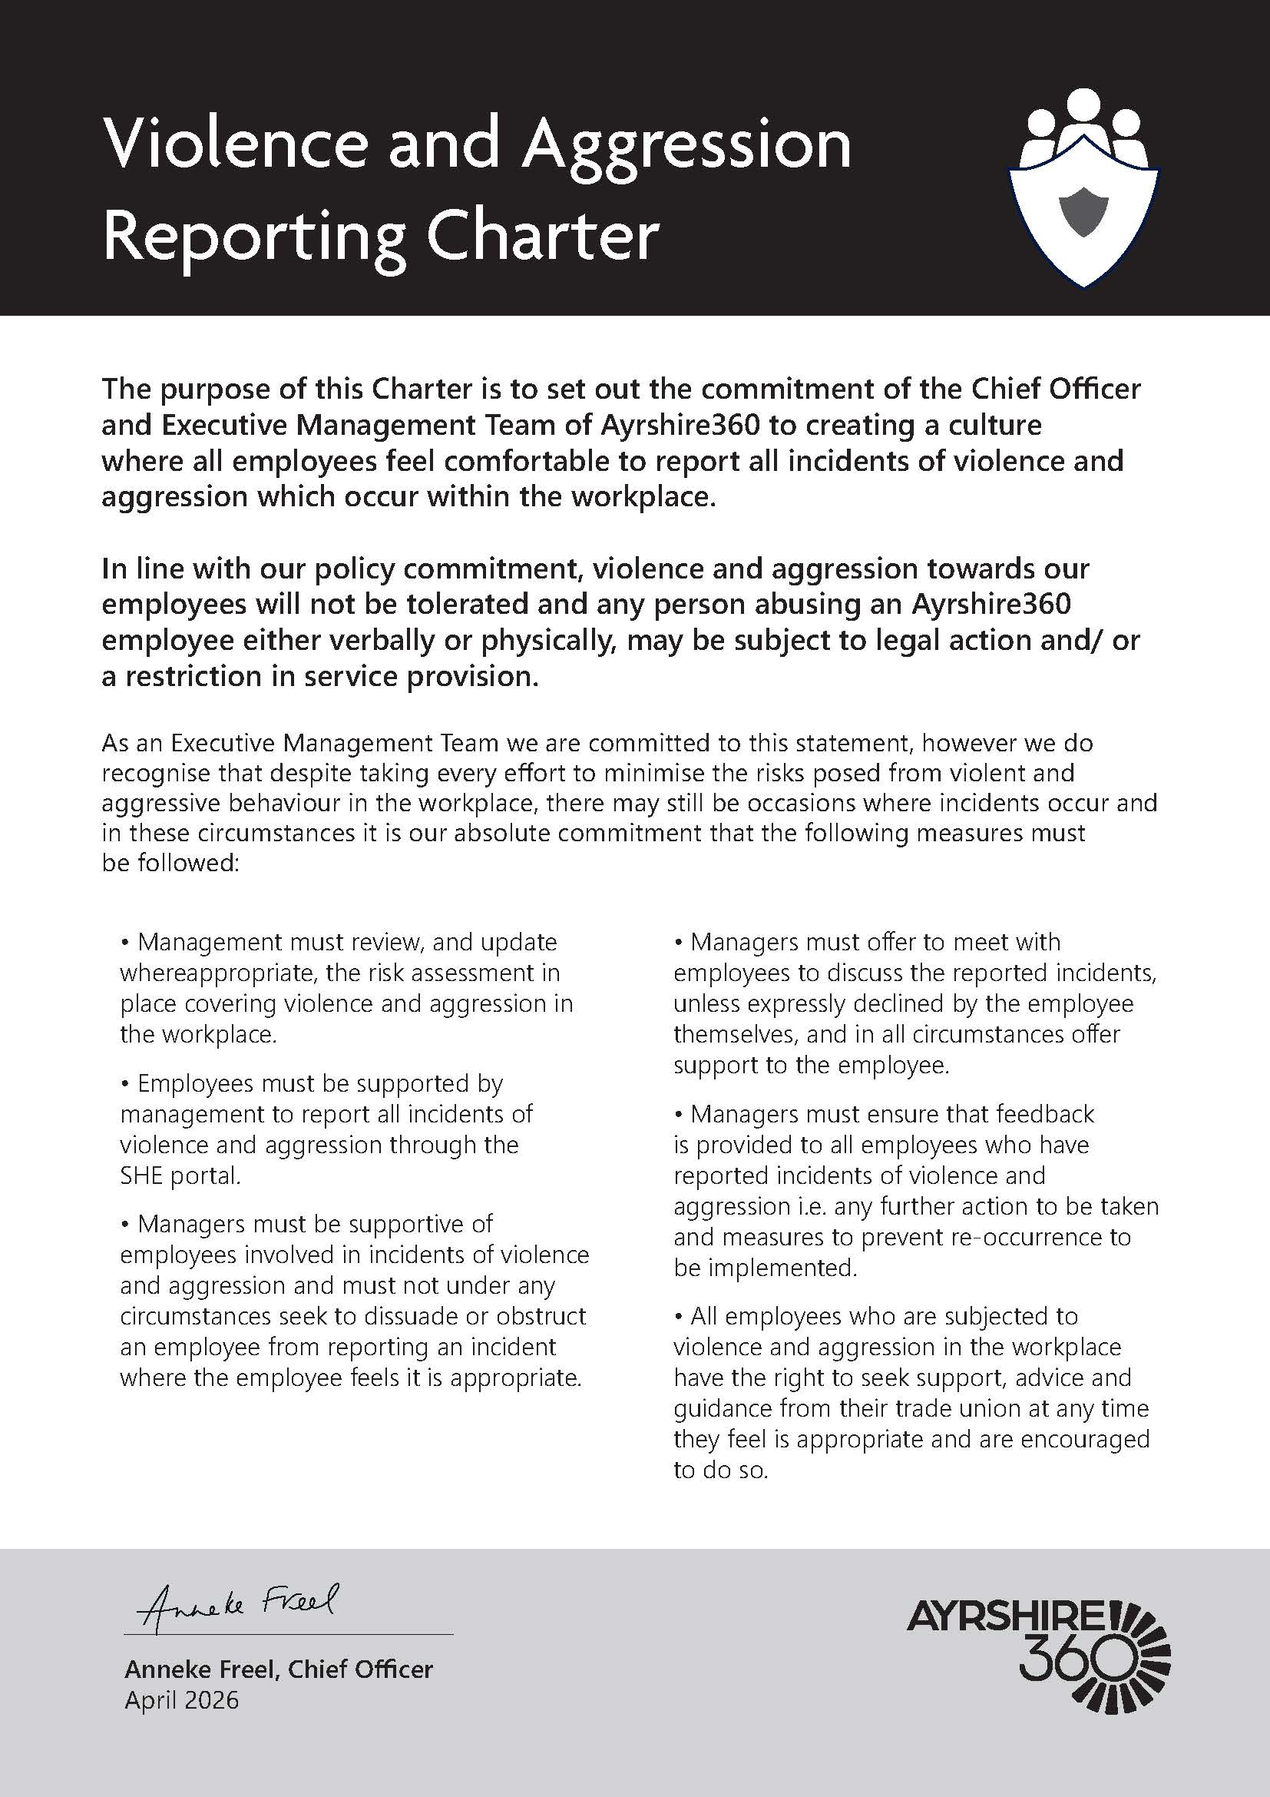

VIOLENCE AND AGGRESSION INCIDENT DEBRIEF GUIDE FOR MANAGERS

The purpose of this guide is to provide advice and assistance for managers, investigating and monitoring incidents of violence and aggression reported via the SHE Incident Reporting System (SHE).

Employees must be encouraged to report all incidents, including verbal or written abuse and proportionate and sensitive support should be provided to them following an incident.

Employees often don’t report because they:

- Think dealing with aggressive customers, service users, pupils or members of the public is part of their day-to-day job
- Think that it will make them look incompetent or at fault for the incident
- Find the reporting process difficult
- Believe that no action will be taken
- Think they will end up with more work or experience stress as a result.

Following the incident, if reported to the line manager verbally or via email, ensure the employee or delegated SHE inputter, enters the information on the SHE system. If an employee is unsure how to report or needs refresher training, further information including user guides and links to the Learn Pro module can be found on the intranet.

Incidents of violence and aggression can impact on people in different ways, such as:

- Loss of self confidence
- Insomnia/nightmares/disturbed sleep
- Anger
- Anxiety
- Depression
- Guilt
- Difficulties completing or performing tasks
- Absenteeism
- Fear
- Feeling incompetent
- Increased use of alcohol, caffeine and/or medication
- Varying degrees of stress including Post Traumatic Stress Disorder (PTSD).

The action required immediately following an incident will depend on the nature of the incident and how it has affected those involved.

For example, giving the employee the opportunity to discuss an incident of verbal abuse with a line manager or colleague and providing friendly support, may be sufficient. The line manager should record this action in the SHE Incident record.

Actions to prevent a reoccurrence should always be discussed with the employee so that they are given the opportunity to put forward their thoughts on appropriate interventions and controls.

In the event of a more serious incident, immediate actions would include:

- Ensuring those involved are safe and offered support, e.g. someone sitting with them, or staying on the phone/arranging someone to visit them if they are working alone
- Arranging any medical care that may be required
- Contacting the Police and other agencies as required
- Securing the premises and any evidence
- Being clear on who will take charge of dealing with the incident and related communications
- Giving the employee adequate time to recover from the incident before returning to normal duties
- Providing any further advice which may be necessary
- Ensure investigation and follow-up actions are undertaken

After the initial/immediate actions, offer employees including those indirectly involved, such as witnesses (including colleagues) the opportunity to talk openly about the incident and how they are feeling with their line manager, or other members of staff as appropriate.

They may not be ready to talk at the time this is offered, therefore ensure they know they are able to have the discussions at a later date should they wish to. Some people may not want to talk about it at all and if this is the case, record on the SHE system that this support was offered.

It may take some time for the after effects of the incident to have an impact, so it is important to review incidents with the employee; have regular contact and offer them a safe space to raise any issues they are experiencing.

Counselling can also be offered via the Employee Counselling Service – which can be arranged by a line manager or via self-referral. Additional or alternative supports can be found via the Support & Wellbeing intranet pages and Wellbeing Support Directory and through the counselling service Vivup.

If an employee is particularly affected by an incident, it may be beneficial to discuss a review of their working arrangements, e.g. temporarily removing them from public facing duties, restrict contact from certain individuals (redirect them to other colleagues). Any proposed changes should be agreed with the employee and guidance sought from the People team, where appropriate, in order to ensure that they are not being exposed to situations which could trigger a stress response from the previous incident

Risk assessments in relation to violence and aggression within the specific service area should be reviewed and updated following an incident, with additional mitigations put in place as required. Depending on the circumstances surrounding the incident it may also be appropriate for an individual stress risk assessment to be carried out.

Upon notification via the SHE system, review the details and record any additional actions to mitigate a recurrence or to further protect the employees.

The employee inputting on SHE should record any known supports for the individual responsible for the incident and record any referrals made to request support they may require. Individual factors, such as disabilities, known mental health issues, etc. should be taken into account when agreeing if any actions are required against the individual.

Ensure the relevant risk assessments are circulated to all employees and that following receipt, they confirm they have read and understood them. Involve employees in the review of relevant risk assessments, to seek their input on the effectiveness of existing control measures.

Ensure health, safety and wellbeing are standing items on agendas for team meetings and one to ones and encourage employees to raise any concerns or issues with their line manager.

