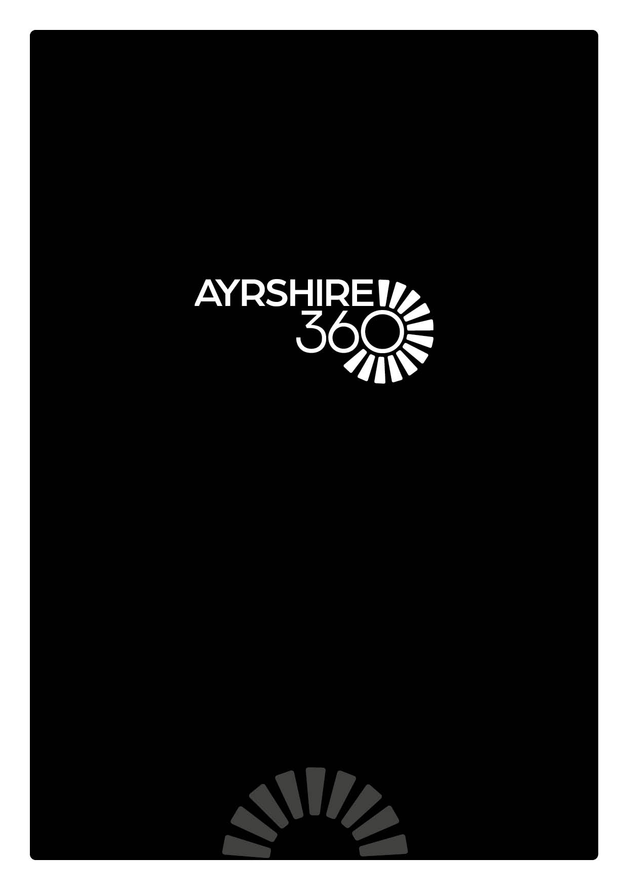
Social Media Policy

SOCIAL MEDIA POLICY

Introduction
This Social Media Policy is intended to help Trust staff make appropriate decisions about their use of social media and provides guidance for employees in relation to acceptable use of social media whether for work or in their personal life. The policy covers individuals working at all levels and grades, including managers, officers, employees, part time and fixed term employees, casual, bank staff and volunteers.

Staff are expected to comply with this policy at all times to protect the privacy, confidentiality and interests of the Trust, its employees, partners and customers. Breach of this policy may be dealt with under Disciplinary Procedures and in serious cases, may be treated as gross misconduct leading to dismissal.

Staff must complete the Cyber Awareness course which is available via LearnPro. In addition, staff must adhere to current policies regarding Data Protection Policy, Information Security, Personal Data Breach Policy and the Code of Conduct Policy (particularly Section 13 on the use of Social Networking Media).

Social media is now part of modern life and the widespread availability and use of social networks provides valuable and cost effective opportunities for enhancing communications and engagement with residents, businesses, partners, colleagues and communities.

The Trust currently uses a number of social networks including Facebook, Twitter, Instagram, LinkedIn and YouTube.

Social media has a positive impact on many areas, including:
- Ease of networking
- Speed of dissemination of information
- Ability to reach wider audiences
- Reduced/nil cost of dissemination of information
- Positive environmental impact

This Policy provide a framework for all employees that support and promote the safe, ethical and responsible use of social media across the whole organisation. This policy aims to:

- Facilitate improved communications, information sharing and engagement with key audiences and wider communities
- Promote a managed approach to social networking within the Trust allowing responsible interaction through social media in a way that enhances communications and engagement
- Encourage employees to collaborate and communicate effectively online
- Encourage employees to be aware of the benefits of social networking and how it can benefit services and the organisation;
- Protect the reputation of the Trust, its services and its employees
- Ensure that the Trust and its employees comply with legal requirements
- Protect the Trust and its services from legal risks
Strategic Leads’ Responsibilities
Strategic Leads are responsible for selecting suitable members of staff to manage and populate social media channels within their department. Similarly they are responsible for ensuring that members of staff who leave the employment of the Trust have their access to accounts removed to maintain security.

Prior to requesting an account, please consider the reasons for using social media and whether the overall investment is worthwhile.

Social media accounts require constant monitoring and updating; maintaining an account is not a one-off task, but involves an ongoing time commitment to establish and sustain engagement levels.

Please refer to the Social Media Access Protocol

Employee Responsibilities
Staff should be aware that statements made on social media platforms could have implications for their employment with the Trust.

Social media presents a risk of potential damage to our IT networks and as such you are expected to approach the use of social media responsibly and with care. Employees are expected to use social media in an acceptable and appropriate manner at all times, referring to support materials the Trust to promote ethical, safe and responsible online communications.

Employees participating in social media are expected to demonstrate the same high standards of behaviour as when using any other media and when representing the organisation. Using social media in your capacity as an employee of the Trust puts you in a position where you may affect the organisation’s reputation, for better or worse.

The Trust respects employees’ rights of privacy and freedom of expression but requires to protect its reputation arising from employees’ comments online as it can be held accountable for discrimination by employees if comments made online amount to harassment, racism etc.

The lines between what is public and private, personal and work can sometimes be unclear to those reading posted material online and therefore any references to working for the Trust should be avoided.

As an employee, you must take the following into consideration when using social media in any capacity - personal, for professional development, or officially on behalf of the Trust:
- If you are acting in your official capacity, make this clear and identify yourself
- Separate business social media accounts from those accounts you use in a personal capacity
- Be aware of your association with the Trust in online spaces
- Ensure your profile and related content is consistent with how you wish to present yourself with colleagues, customers and stakeholders
- Be aware of your language and conduct. You are the face of the Trust. Do not post content which does not comply with the Employee Code of Conduct
- Never share personal, confidential or sensitive information - to prevent the possibility of cyber-bullying, false allegations or misinterpretation of information.
- Ensure all content, pictures and videos are appropriate for use and do not breach any GDPR policies or copyright.
- Do not publish photographs of children, young people and vulnerable adults without the explicit consent of parents/carers.
- Try to add value by providing worthwhile information – what you publish will reflect on the wider organisation.
- If you mistakenly publish something restricted or sensitive, inform your line manager immediately.
- It’s easy to get involved in a controversy unintentionally – do not engage in online conversations of they are in danger of escalating. If you think you have stepped into a firestorm, inform your line manager immediately. Do not offer personal opinions on any posts or online conversations.

Points to Remember
Employees must only use official corporate social media sites for communicating Trust business. All corporate social media accounts must be set up by the Marketing & Tourism Team. Employees must not create corporate social media accounts independently.

Prior to requesting an account, consideration must be given to the reasons for using social media.

Social media accounts require constant monitoring and updating; maintaining an account is not a one-off task, but involves an ongoing time commitment to establish and sustain engagement levels.

Social media accounts must not be neglected - this could have a negative impact on the Trust’s brand, image and reputation.

Best Practice
- Keep passwords confidential
- Be careful about what is posted online; do not reveal home addresses, telephone numbers or other personal information.
- Report any inappropriate comments or abuse of official social media sites. If in doubt please speak to your line manager. The Marketing & Tourism Team can offer advice on these matters.
- Do not contact vulnerable adults, or any child or young person under the age of 13 years through social media and decline any friend requests from these groups.
- Similarly, do not use social media to contact family members of any child, young person or vulnerable adult if that contact is likely to create a conflict of interest or call into question their objectivity.
- In all instances, please obtain relevant permissions prior to posting photographs, videos or any other types of image of individuals on social media. The Media Consent Form must also be completed
- Do not use work email addresses and other official contact details when communicating through personal social media accounts.
- A breach of these guidelines may result in a breach of confidentiality, or defamation or damage to the reputation of the organisation, service or establishment, or any illegal acts or acts that render the Trust liable to third parties.

Additional Social Media Guidelines for Staff posting to our platforms
Please refer to the Social Media Guidance document for further tips and guidelines and restrictions before posting on Trust platforms.

Non-Compliance
Where an employee’s participation with social media is brought to the attention of the Trust, in the form of a formal complaint or via some kind of publicity, and dependant on the nature of the complaint, this may require further investigation and may be subject to the Disciplinary Policy and Procedures.

Posting discriminatory, harassing, defamatory remarks online or creating a hostile working environment for another employee could constitute Bullying and Harassment and serious misuse of social networking sites is regarded as Gross Misconduct and may lead to dismissal.

Conclusion
Employees who come into contact with the public in the course of their duties have to ensure the trust and confidence of our customers and should therefore consider carefully the impression they want to portray on social media sites.

The best advice is to approach the online world in the same way we do the physical one – by using sound judgement and common sense.
- Treat people with respect and avoid speaking negatively about other people, companies or organisations.
- Remember that everything on the internet is public. Customers and colleagues may well have access to the content or images you post online and information originally intended for only friends and family can be passed on and traced back. Always assume your social media communication is visible to everyone, everywhere.
- You are responsible for what you write and should stick to what you know. Comments, posts and images are public and permanent even with privacy settings in place. Try to ensure your posts are accurate and not misleading and be careful not to reveal confidential information. If you’re not sure, don’t post it. As in the “real” world any inappropriate comments made in the virtual world may be reviewed by your line manager

Record of Change

Date Reviewed
September 2023

