

WORK EXPERIENCE POLICY

Index

Page No

1. Introduction 3

2. Ambition 3

3. Scope 3

4. Equalities 3

5. Arranging Work Experience Placements 4

6. Remuneration 5

7. Health and Safety Checks 6

8. Record of Attendance 6

9. Protection of Vulnerable Groups – Children & Adults 7

10.BEST 7

APPENDIX 1 – Work Experience Health & Safety Supervisor Checklist
APPENDIX 2 – Work Experience Application Form
APPENDIX 3 – Work Experience Placement Record
APPENDIX 4 – Virtual Work Placements
APPENDIX 5 – Example Work Experience Week
APPENDIX 6 – Work Experience Review & Evaluation

1. INTRODUCTION

1.1 This policy sets out the Trust’s commitment to the provision of work experience placements and sets out the three routes to undertaking work experience placements and the arrangements for set up, management, recording and reporting of them.

2. AMBITION

2.1 The Trust’s overall ambition is to provide a range of good quality work experience opportunities and pathways for young people to be work ready and consider a career with the Trust.

2.2 All services are encouraged to enable work experience placements wherever practicable in support of planning for our future workforce and to support the increase of the number of young people working in the Trust. Services should also consider whether a virtual placement can be offered, taking account of the options that this might include, examples of which are detailed in the attached Virtual Placement documents at Appendix 4.

2.3 In addition to providing benefit to young people as they prepare for work, there are benefits for the Service through provision of placements, including:

- Identifying skill and talent in the potential future workforce Boosting morale of teams

- Developing supervisory, coaching and mentoring skills of existing staff Ability to fast track talent development and address skills shortages Bringing fresh energy and a new perspective to the workplace Accessing digital skills developed by young people who have grown up in the digital age

- Promoting workforce diversity

- Providing future access to a pool of young people able to make more informed choices due to having undertaken work experience

3. SCOPE

3.1 The scope of this policy covers all work experience placements undertaken within the Trust.

3.2 All services should make every effort to facilitate as many work experience placements as is reasonably practical.

4. EQUALITIES

4.1 In respect of Work Experience opportunities, Ayrshire360 welcome applications from young people of all abilities and will take account of any reasonable adjustments required and no person will receive less favourable treatment than any other in respect of the protected characteristics as covered by the Equality Act 2010.

4.2 The Work Experience Policy supports the UN Convention on the Rights of the Child (UNCRC) Article 29 by supporting access to good quality work experience as part of the fuller educational experience.

4.3 The Work Experience Policy supports the Trust’s commitment to “The Promise” which is a pledge consisting a range of supports provided to care experienced young people and includes pledges to make sure young people can access the education they need and give them opportunities to gain jobs, while recognising that they may not have parents who can provide that support.

5. ARRANGING WORK EXPERIENCE PLACEMENTS

Through the Education Service:

5.1 The Education service facilitates work experience placements for young people through:-

- Short term work experience for school pupils every year. This service is managed by the Workforce and Future Skills team who will canvass employers annually to determine the type and length of work experiences they can offer, source placements for pupils and match pupils to placements based on their stated preference, where possible. Set up of these placements and self-found placements referred to the school, including appropriate Health and Safety checks and relevant risk assessments are undertaken by the Workforce and Future Skills team.

- The Workforce and Future Skills team also, on behalf of the Education service, arranges longer term flexible work placements for learners where young people will attend at a workplace regularly over a period of time agreed between the school and employer.

- Work experience placements for young people aged 16 to 19 years who have left school and are being supported through No-One Left Behind work-based activity. The facilitation of these work experience placements, including appropriate Health and Safety checks and relevant risk assessments, are undertaken by the Workforce and Future Skills team on behalf of the Education service.

- Foundation Apprenticeships enable young people, still at school, to develop skills for work and build qualifications whilst still working to the school curriculum. Foundation Apprenticeship placements are a form of work experience, facilitated and supported, including the completion of appropriate Health and Safety checks and risk assessments through Ayrshire College and the 3 Local Authority Education Services.

- Where placements are made through Education Service they will fund travel costs through existing budgets and processes.

Through the Economic Development Service (Skills and Employability):

5.2 The Skills and Employability service supports unemployed people (aged 16 to 65), through a number of different initiatives, to secure employment. This includes access to work experience placements to support the development of work knowledge, skills and behaviour and CV development. The service facilitates work experience placements for young people through:-

- The Skills and Employability service facilitates work experience placements for young people aged 16 and 17 years old and adults 18+ years who have left school or are unemployed and are being supported though the Employability Fund programme which includes access to and support of a team of Work Coaches.

- The Skills and Employability service also facilitates work experience placements for young people and adults with learning disabilities or Autism who are engaged with the Supported Employment team.

5.3 The facilitation and setup of work experience through any of the above routes, including appropriate Health and Safety checks and risk assessments, is undertaken by the Skills and Employability Service.

Directly with Services (Ad Hoc replacements):

5.4 All Ayrshire360 services are approached from time to time by individuals seeking work experience in an area of interest to them or as part of their studies at university. Provision of work experience placements is encouraged.

5.5 Where the work experience placement is arranged directly by the service, a work experience plan should be created for the person attending. An example of what this might look like for someone doing 1 week’s work experience is detailed at Appendix 5. In addition an appropriate Health and Safety checks and risk assessments relevant to the work to be undertaken must be completed by the service. A checklist to support managers to do this is detailed at Appendix 1.

5.6 If we want to encourage greater uptake among young people of posts within the Leisure Trust it is important to gain feedback from those undertaking work experience with us and also sign post them to our recruitment site for suitable posts which may be of interest to them. An evaluation form to be used by the work experience placement and signed off by the manager is included as Appendix 6. This also incorporates an online survey which the candidate can complete themselves in their own time. The link for the survey should be given out on completion of the placement.

5.7 University placements at undergraduate or post-graduate level will generally take place over a period of months. In these instances, students must have an assigned supervisor who will monitor their progress and give feedback. Students may be granted access to Ayrshire360 IT equipment if the placement requires administrative work and this should be arranged via the Trust’s ICT team.

Virtual Work Placements

5.7 The Workforce and Future Skills team have developed a range of ways in which organisations can incorporate virtual work placements in support of young people and attached as Appendix 4 are details of how this might work for your service.

6. REMUNERATION

6.1 This policy supports people gain work experience and as such is unpaid. However should there be a requirement for a work experience candidate to receive an allowance for lunches/travel then this would be managed on an individual basis within service budgets and should be discussed with the person undertaking the work experience as part of their 1 to 1 induction.

6.2 From January 2022, travel by Public Transport will be free for all young people between 16 and 22, however for people over that age completing an ad hoc placement then arrangements can be put in place to reimburse travel expenses if required.

6.3 Should a service decide that after a period of work experience they want to appoint the trainee to a role, for example into a Graduate Intern or into an appropriate apprenticeship, then they must follow the usual recruitment and selection procedures. If you require further information on Graduate Internships or Apprenticeships within the Leisure Trust, please speak to the Development Officer: Volunteering and Placements.

7. HEALTH AND SAFETY CHECKS

7.1 Workforce and Future Skills team on behalf of the Education Service are responsible for keeping a record of completion of Health and Safety checks undertaken by them.

7.2 The Skills & Employability Service keep a record of Health & Safety checks completed by them through a workplace inspection and risk assessment pertinent to the individual undertaking the work experience placement.

7.3 Where a work experience placement is arranged directly with a service, the service providing the placement is responsible for retaining a record of the Health and Safety check completed.

7.4 All Health & Safety records must be available for inspection if requested and must be retained for a period of three years following the date of completion of the work experience placement.

8. RECORD OF ATTENDANCE

8.1 A record is required of all work experience placements undertaken. Placements arranged under paragraphs 3.1 and 3.2 above will be recorded by the relevant service (Education and/or Skills and Employability) in accordance with existing arrangements and safety checks.

8.2 Where a work experience placement is arranged ad hoc per paragraph 5.4 directly with the service it is the responsibility of the Head of Service, or their nominated officer to whom responsibility has been delegated, to complete and hold a record of the placement to include the trainee’s name, contact details and emergency contact details per the form provided at Appendix 2.

8.3 It is important to remember that for a positive experience to be achieved by the person completing the work experience a good quality plan should be in place with clear supervision during the period they are with the service.

8.4 A record of all work experience placements undertaken shall be submitted to the Development Officer: Volunteering and Placements as placements are accepted. This record should be submitted in accordance with the template provided at Appendix 3 for all work experience placements regardless of how they have been set up.

9. PROTECTION OF VULNERABLE GROUPS – CHILDREN AND ADULTS

9.1 A PVG certificate is not required to supervise a young person on work experience.

9.2 Work Experience trainees aged 16 and over will require a PVG in certain circumstances, e.g. lifeguarding or caring roles. If a PVG is required for a pupil undertaking work experience, the cost of the PVG will come from the school or parent/guardian. PVGs for university placements will be managed by the student’s own university.

10. B.E.S.T.

10.1 Provision of work experience placements reflects the B.E.S.T. qualities and behaviours which Ayrshire360 are embedding within our employment policies. Working together to encourage young people to consider a career in the Leisure Trust supports the 4 key B.E.S.T. values.

Record of Change

Date Reviewed
November 2025


WORK EXPERIENCE HEALTH AND SAFETY SUPERVISOR CHECKLIST
Appendix 1

Placement Name:
Placement Location:
Does the trainee require any reasonable adjustments in relation to the Equality Act 2010? (refer to application form)
If Yes, What are they?
Development Officers and coordinators must agree on suitable tasks for the trainee to carry out and communicate these to all staff who will supervise the trainee.
Who will deliver the trainee’s induction to include relevant training in all areas relevant to the tasks they will be carrying out with any hazards highlighted and appropriate risk assessments in place? |  | Please Specify staff member:
Although work experience candidates should not be prohibited from gaining practical, hands on experience where it is critical to their development, the service must ensure the following measures are implemented before the trainee starts work (each must be checked off):

Full and thorough risk assessment of work task has been carried out. | ☐
Induction training is provided. | ☐
Appropriate information, instruction and guidance is provided for the work to be undertaken by the trainee | ☐
Appropriate supervision by a competent person is provided at all times. | ☐
Appropriate PPE is provided for the work to be undertaken and the trainee inducted on its use. | ☐

Particular attention must be given within the risk assessment to any significant risks arising from the work the trainee may be expected to undertake bearing in mind their appreciation of the risks and their inexperience. A selection of common risks are highlighted below, and should be checked off as they apply. In cases where they do apply they must be suitably controlled within the risk assessment:

- Lone working. | ☐
- Working with children or vulnerable adults. | ☐
- Undertaking tasks associated with personal care | ☐
- Working at height | ☐
- Using knives, sharp objects or cutting equipment | ☐
- Working with machinery | ☐
- Hot works or working with burning equipment (blowtorches etc.) | ☐
- Working on electrical circuits | ☐
- Working with or on any motorised machinery or equipment | ☐
- Working with chemicals or substances (unless identified as being low risk or inert through a COSHH assessment) | ☐
- Working with power tools or compressors | ☐
- Manual Handling | ☐

NOTE: THE LIST ABOVE IS GIVEN AS A GUIDE TO HELP IDENTIFY SIGNIFICANT RISKS, HOWEVER IT IS NOT EXHAUSTIVE. THE RISK ASSESSMENT MUST IDENTIFY AND RECORD ANY SIGNIFICANT RISKS ARISING FROM THE TASKS TRAINEES WILL BE UNDERTAKING IN THE WORKPLACE ALONG WITH THE CONTROLS IN PLACE TO CONTROL THOSE RISKS, AS FAR AS PRACTICAL. IF YOU REQUIRE ASSISTANCE OR GUIDANCE CONTACT THE DEVELOPMENT OFFICE FOR VOLUNTEERING AND PLACEMENTS.

Controls may include, as an example:

- A competent employee demonstrating the task to the trainee so that they learn without undertaking the task themselves until they are deemed competent to do so.
- Close one-to-one supervision from a competent person when the task is being undertaken by the trainee (following a suitable period of training).

WORK EXPERIENCE APPLICATION FORM
Appendix 2

Name:
Tel No (personal or guardian’s):
Email (personal or guardian’s):
Work Experience Location:
Payment of Travel Expenses Required (travel expenses can be claimed if trainee does not have access to free public transport) | Yes ☐ No ☐
Travel Expenses Claim Form Completed | Yes ☐ No ☐

Access Requirements
If you have any access requirements or health conditions (e.g. medication or allergies etc.) that we should know about please tell us about them here

Ayrshire360 aspires to the highest standards; this is why we have adopted the following values that will be embedded within our organisation through our service delivery, customer and partner engagement and through our staff and volunteers:

- Being honest and demonstrating integrity at all times
- Engaging and inclusive with our people, partners and communities
- Striving for continuous improvement by being ambitious and aspirational in all that we do
- Taking responsibility and being accountable for our organisation and our service delivery

We want all our volunteers to share the values that will help Ayrshire360 provide high quality services for all our customers and communities.
Will you commit to demonstrating these values during your work experience with us? | Yes ☐ No ☐
Why have you decided to carry out work experience with Ayrshire360:

Emergency Contact Details
It’s very important that we have up-to-date emergency contact details for all our work experience placements. Please let us know if this information changes:
Emergency Contact Name:
Relationship to you:
Tel No:
Address:

We will treat this information in accordance with the General Data Protection Regulations and the Data Protection Act 2018 and personal information will not be sold to any third parties. By supplying us with your email address you are consenting that you are willing to receive future mailings from us. You have the right to withdraw this consent at any time and can do so by unsubscribing on any marketing email received from us. For further information on the use of your data you can view our policy statement at: ayrshire360.com or email us at: info@ayrshire360.com

WORK EXPERIENCE PLACEMENT RECORD
Appendix 3

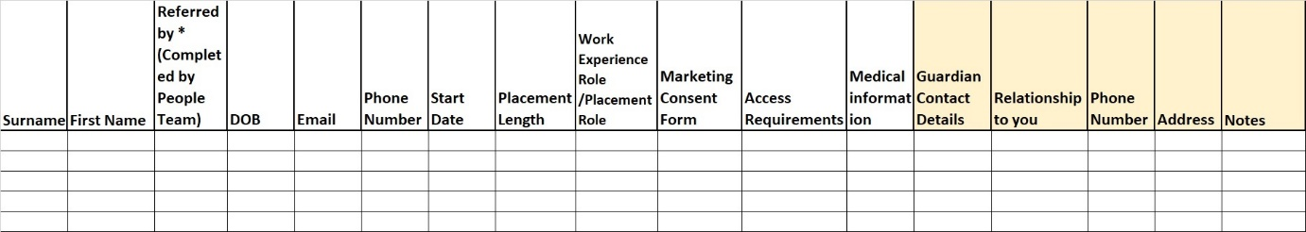
VIRTUAL WORK PLACEMENTS
Appendix 4

Virtual Work Placements (VWP) provide young people with a relevant, challenging, enjoyable and appropriate online, interactive learning experience delivered in collaboration with employers. The VWP is to be based on the current industry working practices and contemporary workplace environment. The experience should help the young person to gain up-to-date information and insight in a specific area of work in order to make informed decisions about their future careers. (Education Scotland 2021)

A Virtual Work Placement can include any of the following component parts

- Online discussions/meetings with company representatives/mentor;
- Virtual company tours/site visits;
- Leaning in virtual work based environments;
- Attendance of online meetings and other work-related activities;
- Virtual shadowing of an employer;
- Online career coaching, e.g. mock interviews;
- Research tasks;
- Employer presentations (live and recorded);
- Personal skills analysis activities;
- Work related project work.

Industry Insight Videos
Industry Insights are a great way to give young people, educators, careers advisors and parents a virtual but visual insight into the world of work. These videos give local employers an opportunity to introduce their company and job roles involved in each area of their business. Insight videos can be used in schools as part of career related learning, link roles to specific subject’s areas or promoted on social media for a wider audience. These videos vary in length from a few minutes to 10-15 minutes depending on the subject and the breadth of job roles covered. Videos can consist of one person or a team of people talking about their roles, it can include a site tour, videos, or other visuals or can simply be a simple self-recording of an individual. By pre-recording material this creates an opportunity for a larger number of schools and pupils to access the resources over and over again. For some schools it will offer a wider range of opportunities for pupils that they may not have had access too, previously due to their location.

Create a virtual activity
Another way for employers and schools to engage is by creating an activity for pupils to work on. This activity could be practical or theory based and be as interactive or non-interactive as the employer wishes. Interactive activities would follow a specific timeline where an employer would set pupils a challenge to work on. This could be a project based on a real life problem or one created to fulfill the task of the school. The employer would make themselves available to speak to pupils and offer feedback on their findings. Non-interactive activity would follow a similar theme to interactive, however, the employer would offer the project brief to the school and in this case there would be no time constraints as the employer would not participate in any interaction after this. The school would use the challenge as and when fits the curriculum. The activities can be a great way to link what is being taught in the classroom to the world of work, allowing teachers to bring their subject to life and help pupils gain a deeper understanding of how that subject can relate to different career paths.

Participate in live sessions
A live session could range from input into the one class studying a particular subject or topic, or a one off event in which you would arrange a date & time for allowing a range of schools to tune in and take part, offering an interactive session with Q&A’s. A live session might also include a virtual tour of the workplace environment, a meet and greet of the departments or teams, setting a challenge for pupils to work on, or could even be more general and have one or two employees talking about the business or sector, their career route and aspirations, and the employment opportunities within that particular sector or career area. Support Teachers/Careers Advisors Participate in a live or pre-recorded session that offers information about your organisation, job roles, requirements of the role, skills, qualifications are required. This will support their work with young people and provide relevant and up to date information to the schools which in turn supports young people.

If a service provides any support or guidance, please email ealvolunteering@ayrshire360.com so that the engagement log can be updated

EXAMPLE WORK EXPERIENCE WEEK
Appendix 5

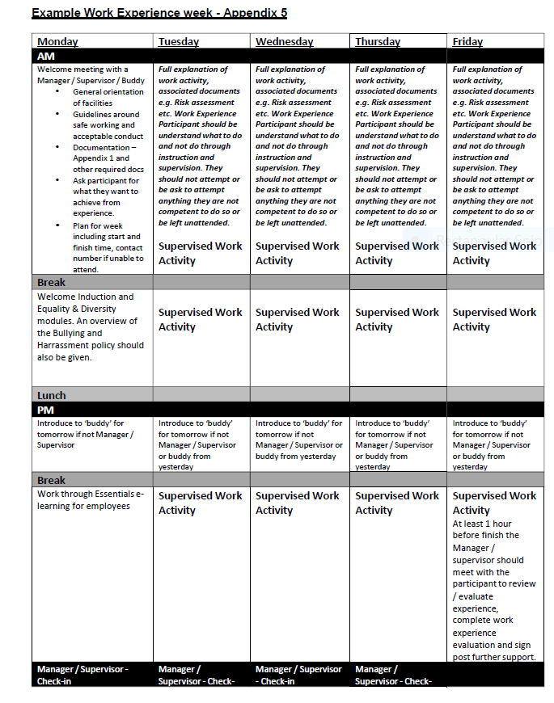

WORK EXPERIENCE REVIEW AND EVALUATION
Appendix 6

Work Experience Placement - Quality Survey

- Your Name

- Location of Work Experience

- Work Experience Role

- Name of Supervisor during your placement

- What do you want to achieve on work placement? Think about things you would like to learn or activities you would like to do.

- What did you achieve on your work placement?

- What support or advice would be helpful for the future?

- Would you consider working for Ayrshire360 in future?

Yes ☐ No ☐

All job vacancies at Ayrshire360 are advertised at myjobscotland.gov.uk. Scan here to go to the website, where you can view what’s currently available and create job alerts.



